Hosting Website:-

Creating VPC

Creating public and private subnet

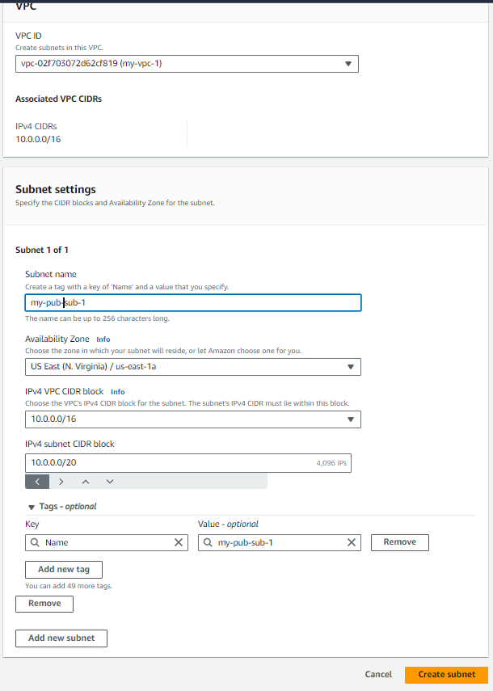

Creating Internet-Gateway

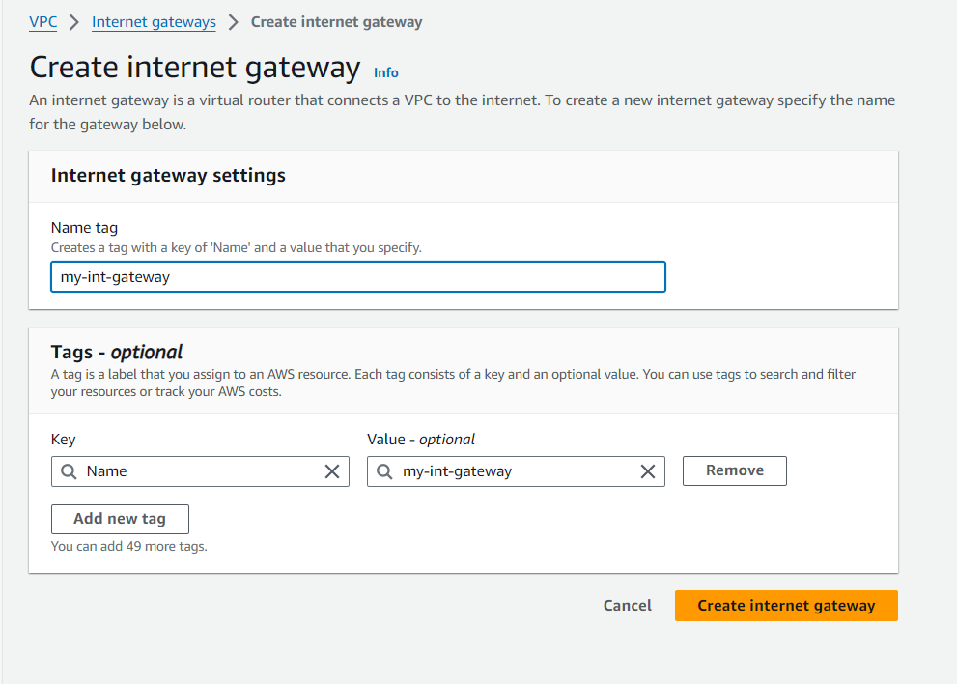

Attaching VPC to Internet Gateway

Creating Route-table and editing explicit subnet association and adding public subnet

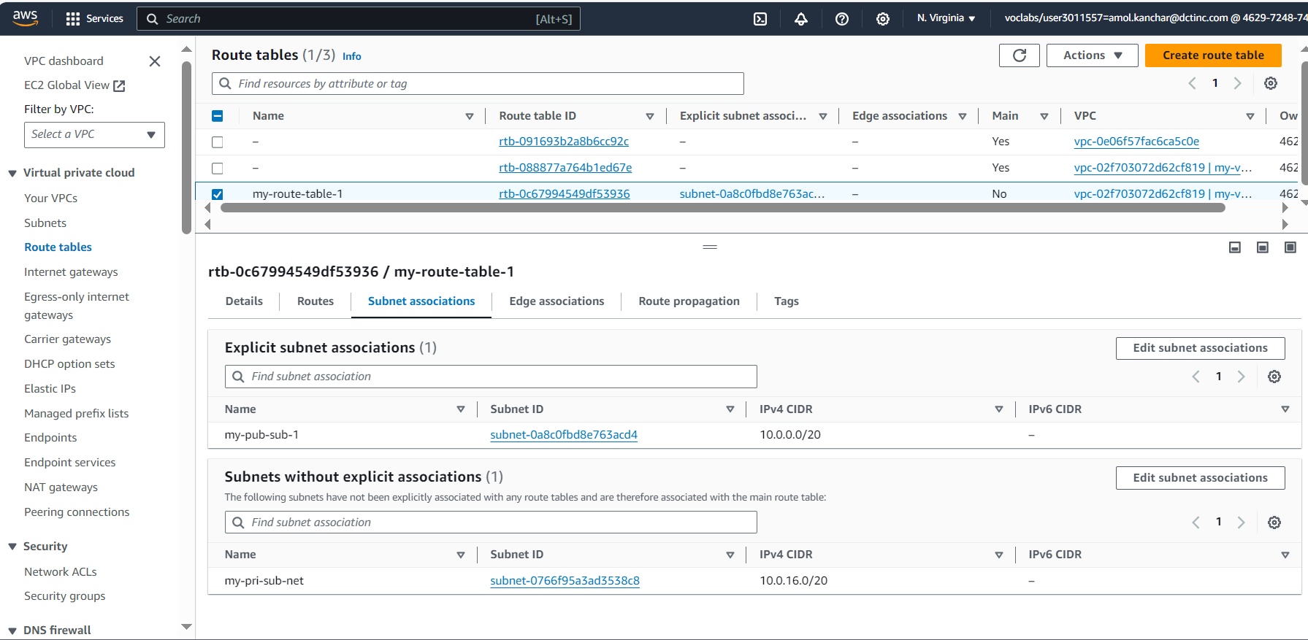

Editing Routes

Creating EC2 Instance

Connecting EC2

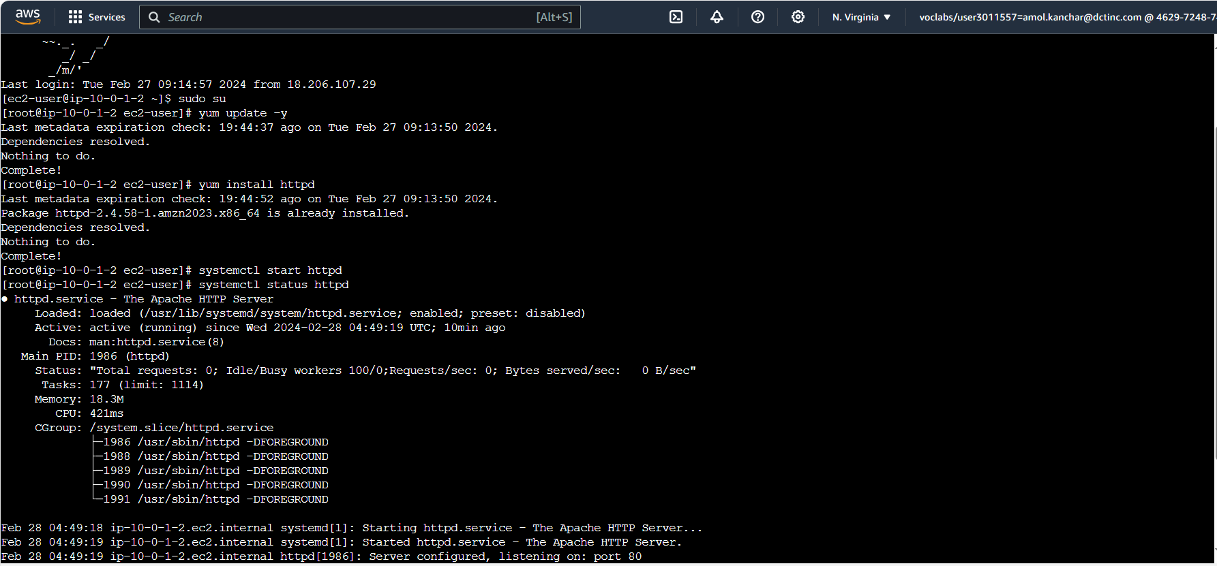

Transferring html file from local machine to remote machine

Creating EC2 with Windows Machine AMI

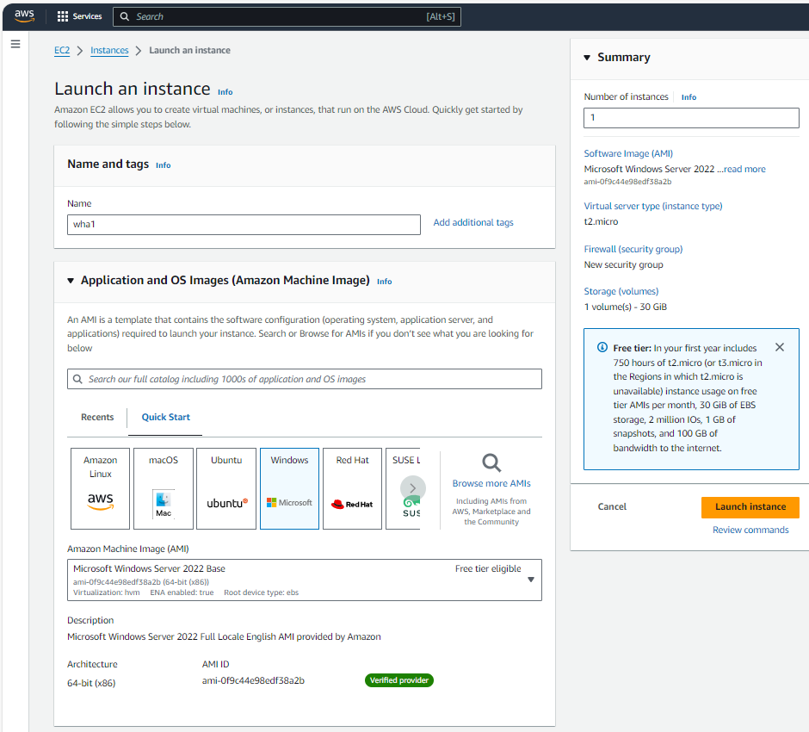

Adding RDP in security group of instance

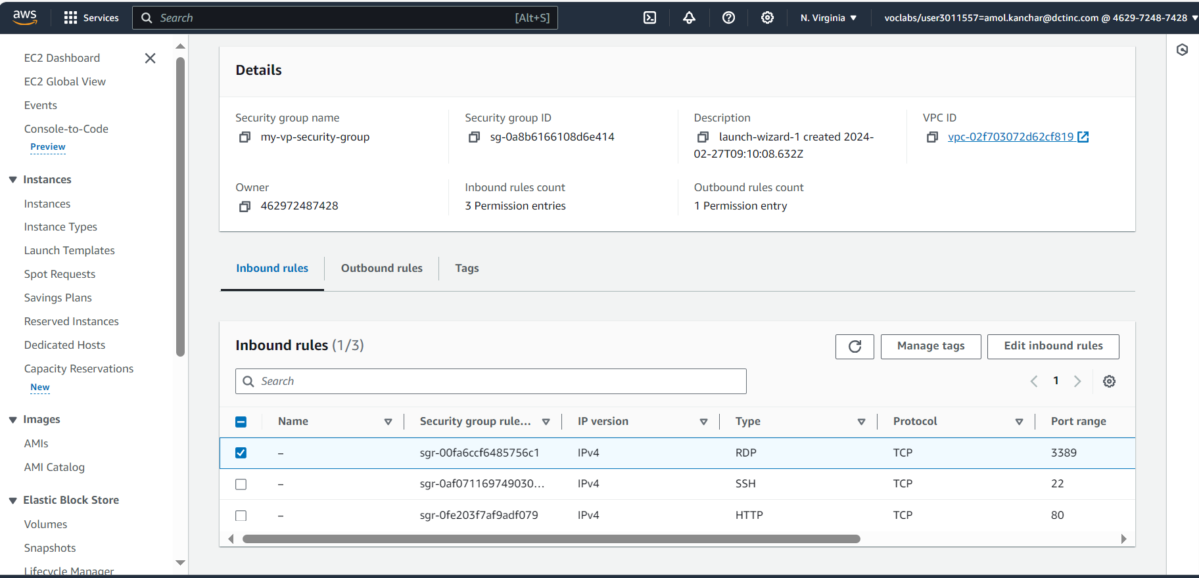

Connecting EC2 using RDP client, downloading Remote Desktop File:-

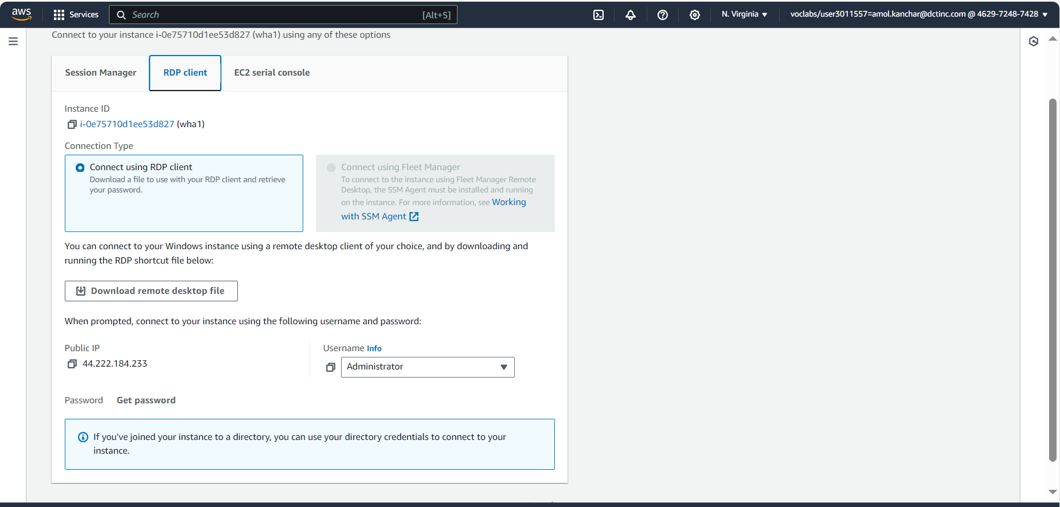

Opening Remote Desktop Connection on local machine and in connection settings open file where RDP file is downloaded:-

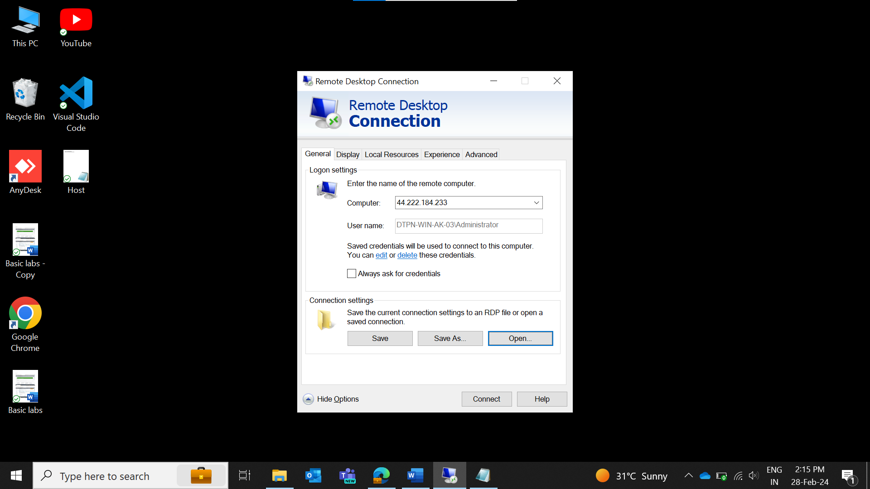

Then going on local resources, click on more and give access to drive where your html file is located

Then connect and get password from EC2 connect:-

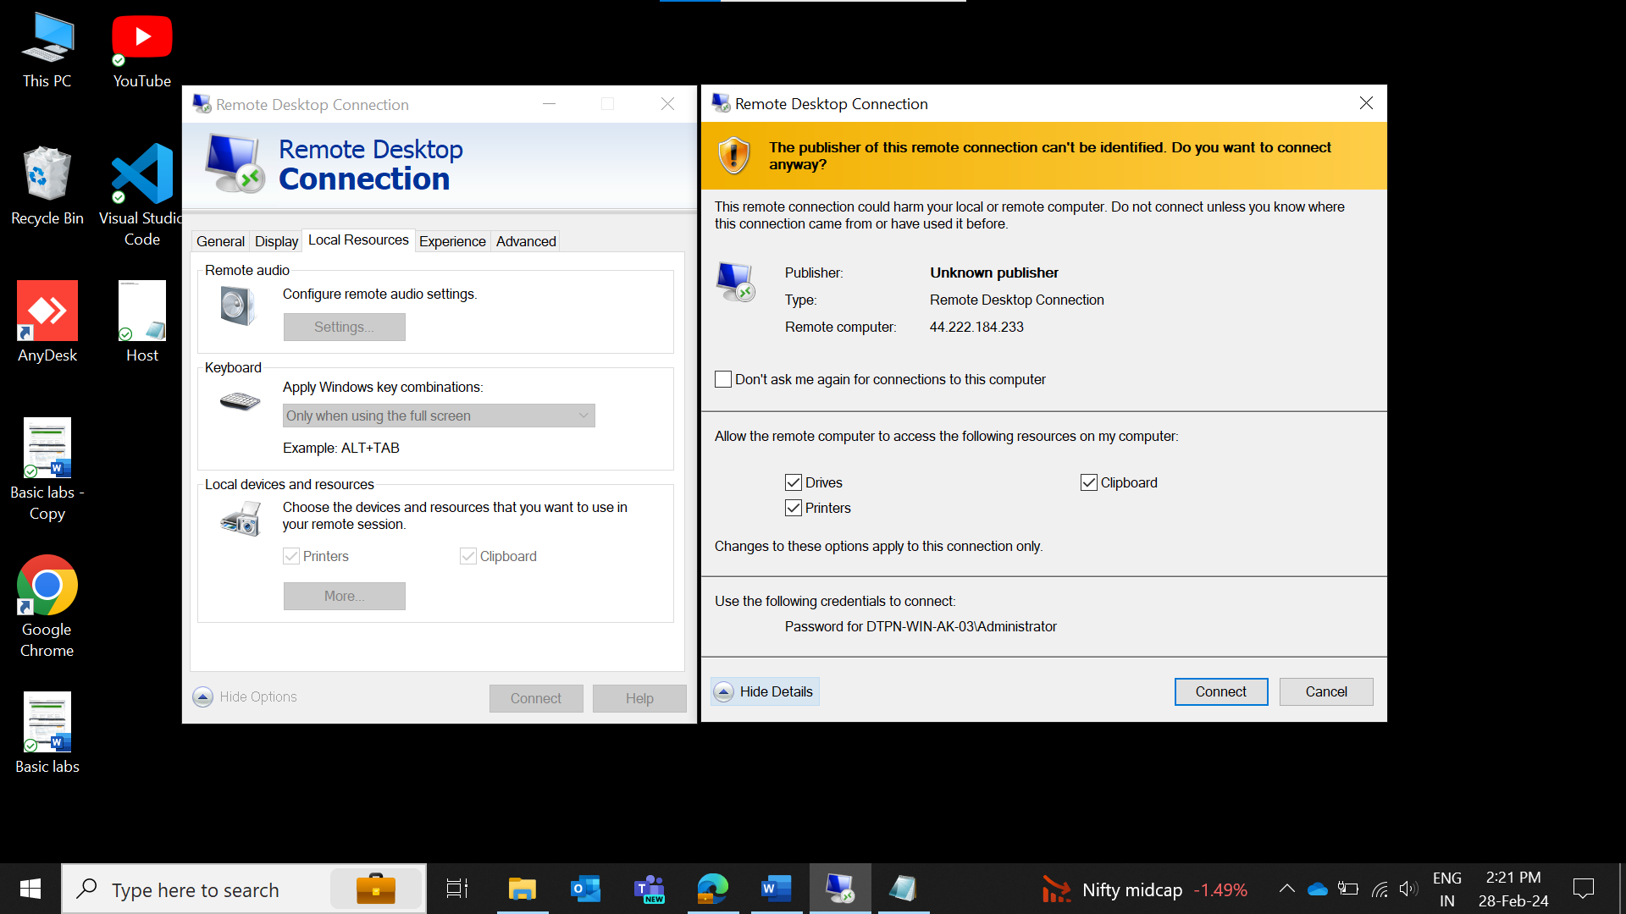

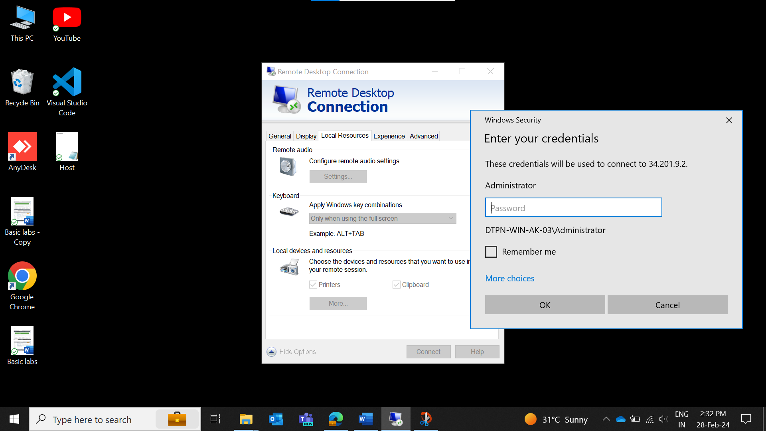

Connecting Windows AMI:-

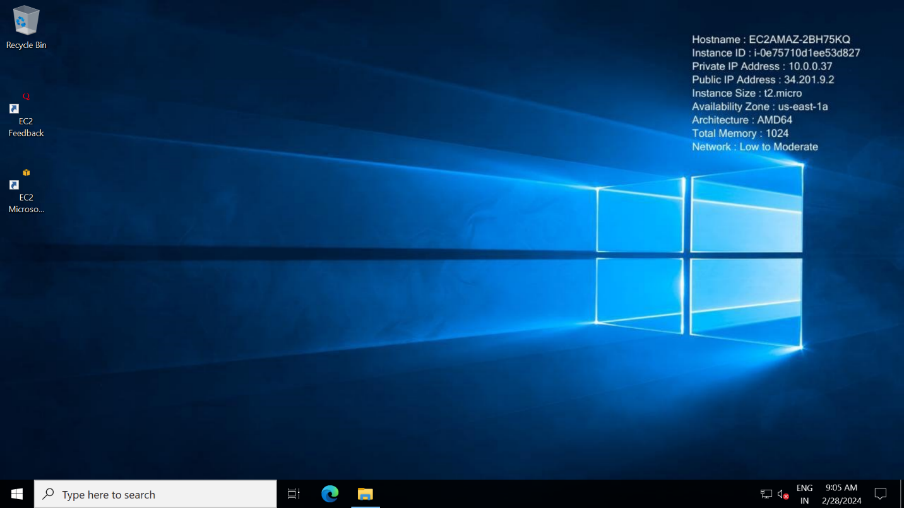

Download python in EC2 machine and open cmd where html file is located:-

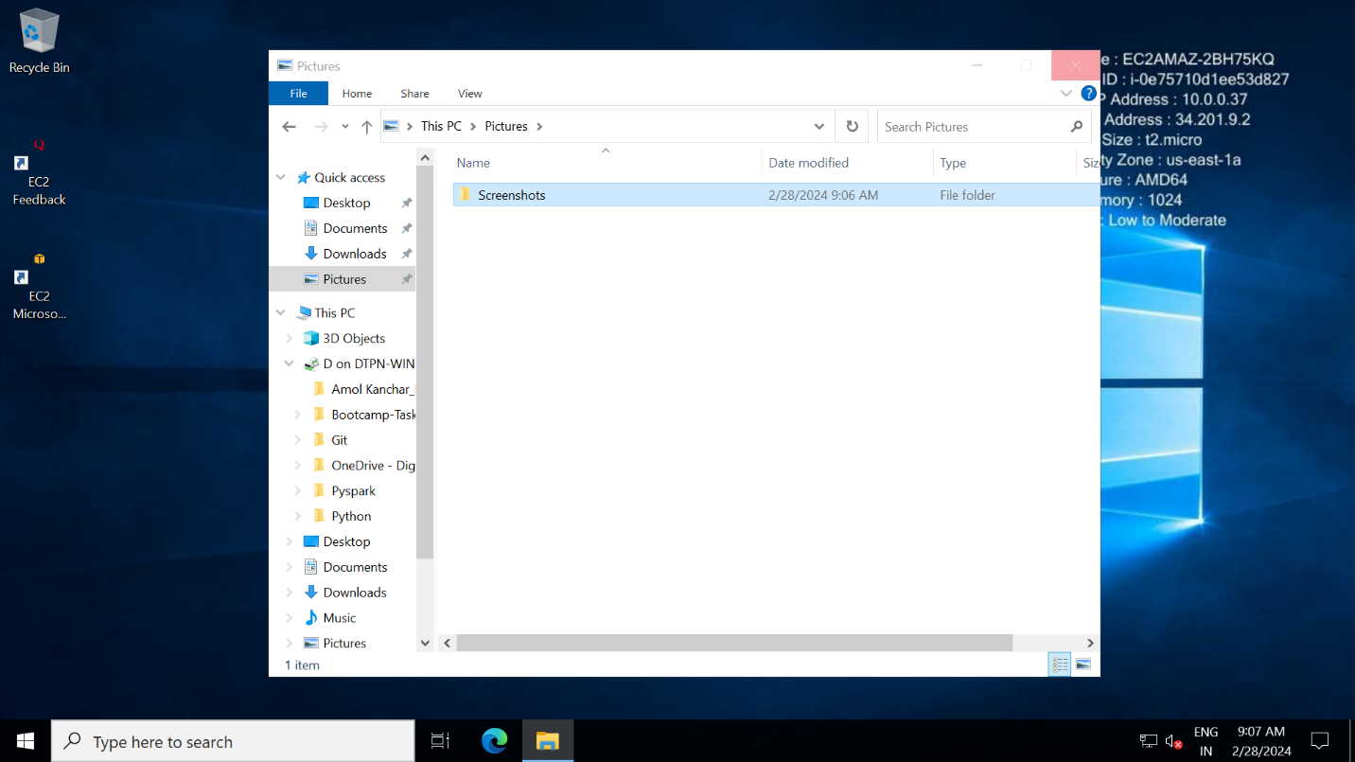

Then going to web page and type localhost:8000

